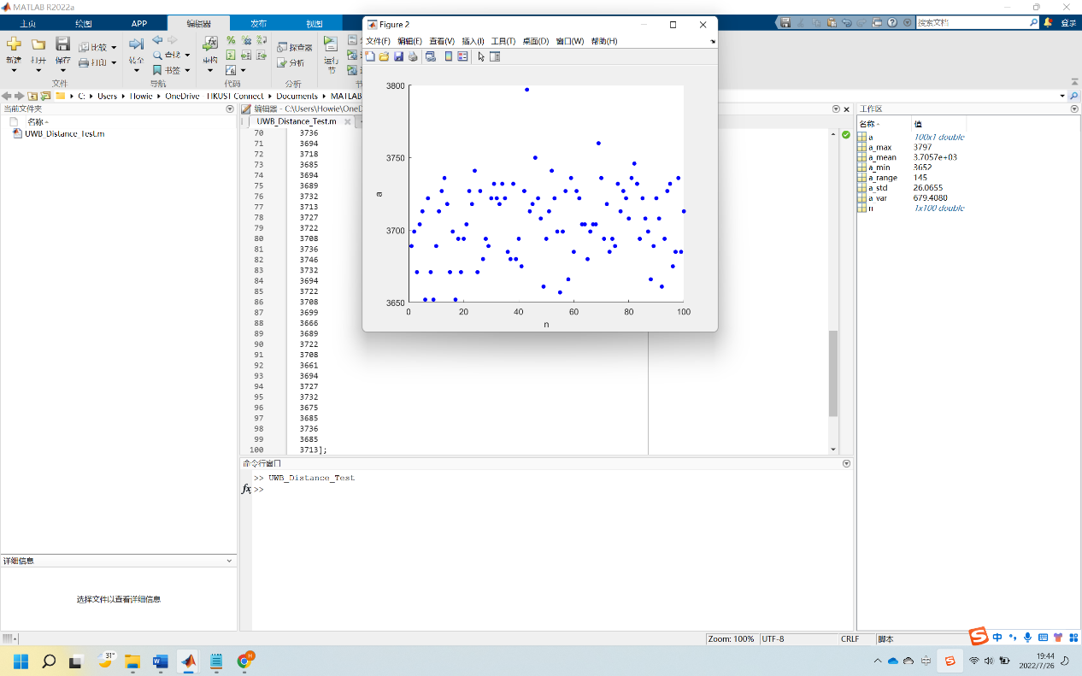

Close distance (in mm):

Max: 3797

Min:3652

Mean:3705.7

Range:145

Std:26.0655

Var:679.4080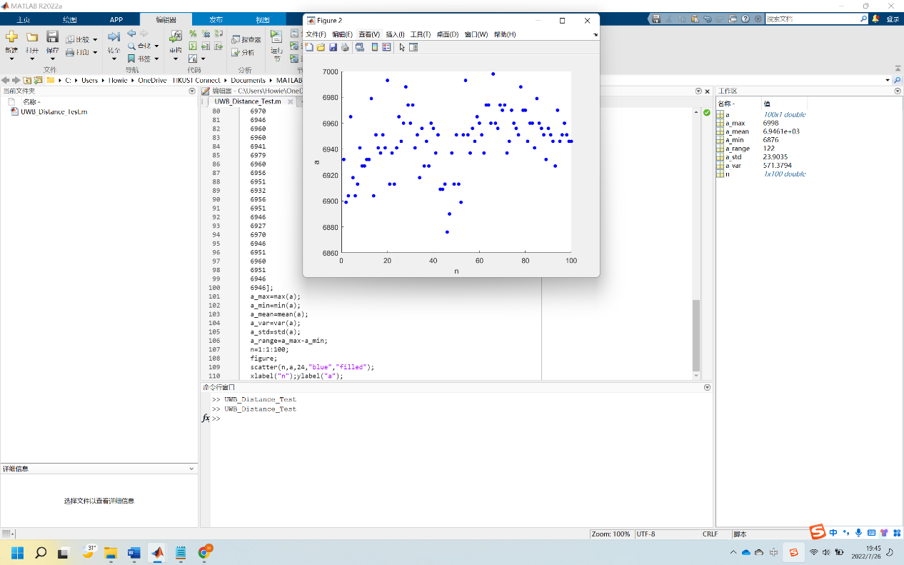

Medium distance (in mm):

Max: 6998

Min: 6876

Mean: 6946.1

Range: 122

Std: 23.9035

Var: 571.3794

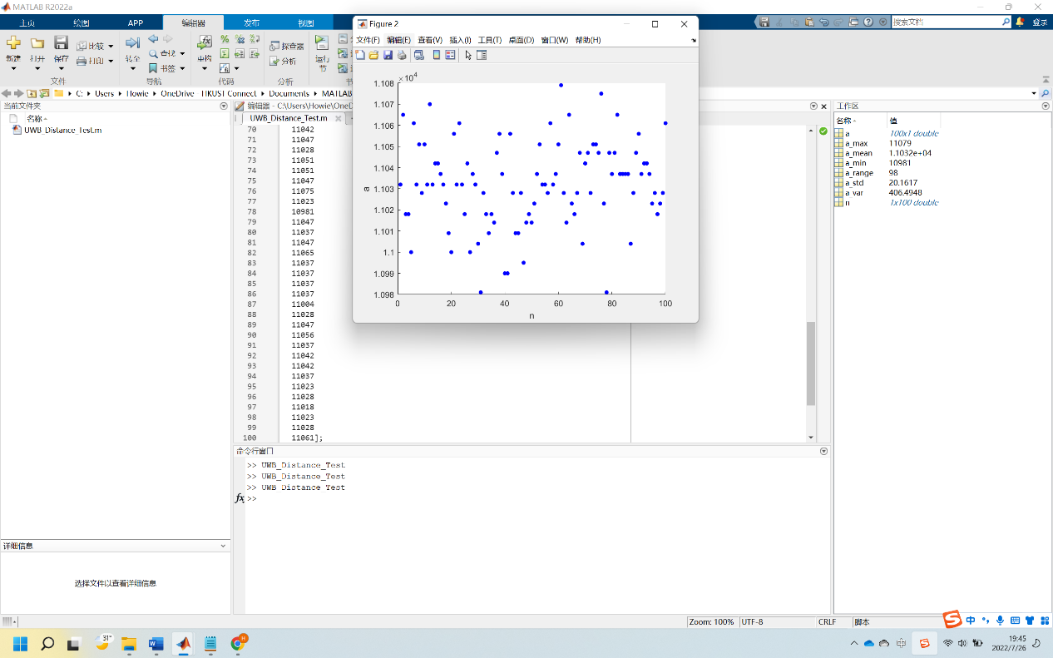

Large distance (in mm):

Max: 11079

Min: 10981

Mean: 11032

Range: 98

Std: 20.1617

Var: 406.4948

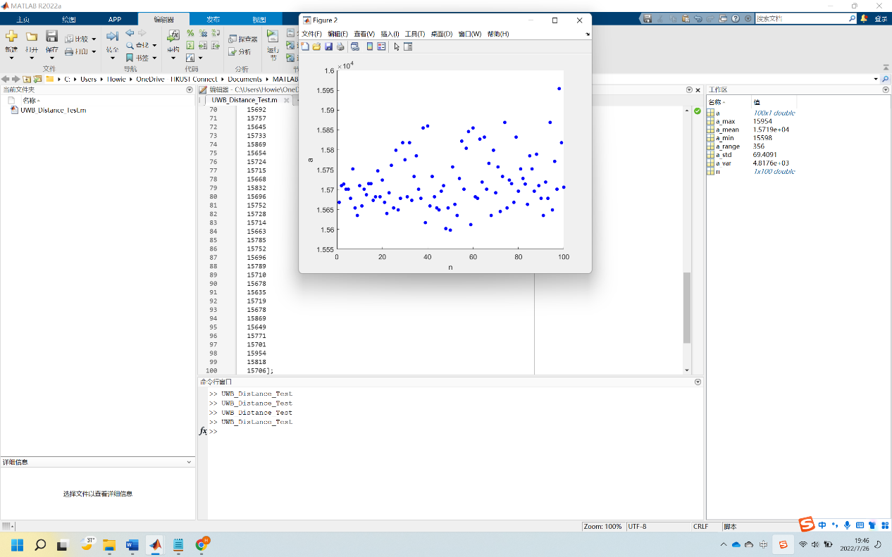

Extra Large distance (in mm):

Max: 15954

Min: 15598

Mean: 15719

Range: 356

Std: 69.4091

Var: 4817.6